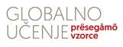
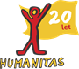

WORKSHOP ON IDENTITY AND PREJUDICES
Greetings to everyone who is eager to share experiences and knowledge in a form of informal and peer-to-peer learning!
You are welcome to take part in international (?) workshop in an EPTO method
(https://www.epto.org/ ). The project is financially supported by the European Union, in Slovenia it is conducted by Humanitas (https://www.humanitas.si/ ). EPTO is a program which promotes consciousness about respecting differences between us and addresses different kinds of discrimination. EPTO is educating young mentors and activists who are tackling these topics on local level.
Here it's on all of us!
The workshop will take place in the centre of Ljubljana (youth centre BOB and ULCA) in the course of three days in April (8.,9.,10.), all together cca. 18h (don't worry, it just sounds a lot!;)). The workshop will be conducting by us, Tajda and Veronika, young mentors on our way to achieve the EPTO trainers title.
What will we be doing?
We will deepen understanding our own identity and internalised prejudges through experiential informal learning on the basis of peer-to-peer information exchange. We will make good use of space by creating and participating in different creative and dynamic exercises and inspect discrimination and different methods of confronting it, it will involve bit of introspection, soft skills and collaboration!
This workshop is a great opportunity for everyone, who wants to actively participate in creating better society with more solidarity, and who wants to connect with similar- and different!- minded people.
Workshop is for free, we will provide snacks and lunch at the end of third day, all participants will get certificate of attendance. Due to diverse interest the workshop will be conducted in English language. Number of participants is limited, apply until 7.4.2022 on: tajda.hladnik1@gmail.com.
We are looking forward to meeting you!
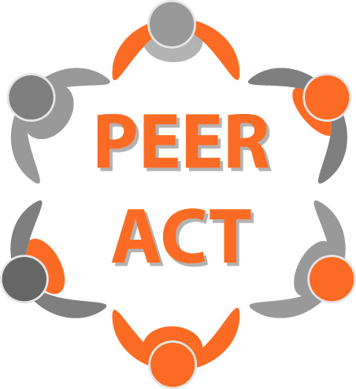
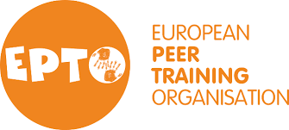

Tajda & Veronika

